**Femi-nazi a curse for men**

Well, isn’t the sole concern behind the feminism is to seek equality and equal positions and rights in the society? Individuality and equality are Feminism and seeking popularity on vague and false accusations are Femi-nazi. There is no harm in fighting for equality and freedom for women. But, why harm or hate men in the process? Today’s men haven’t been the ancient suppressors of women’s rights. Then why punish men on the name of Feminism?

Well, there is evidence why feminism is a need for this generation’s women as there’s a lot of miss-happenings going worldwide with women. Human trafficking, rape, molestations, harassment, and what not! But, with Femi-nazi in rising, the situation of men is a lot worse, or actually, both men and women are equally suppressed in this decade. Because of the fake feminism, and their fake accusations and gross actions in the name of equality, women who need support and help, suffer!

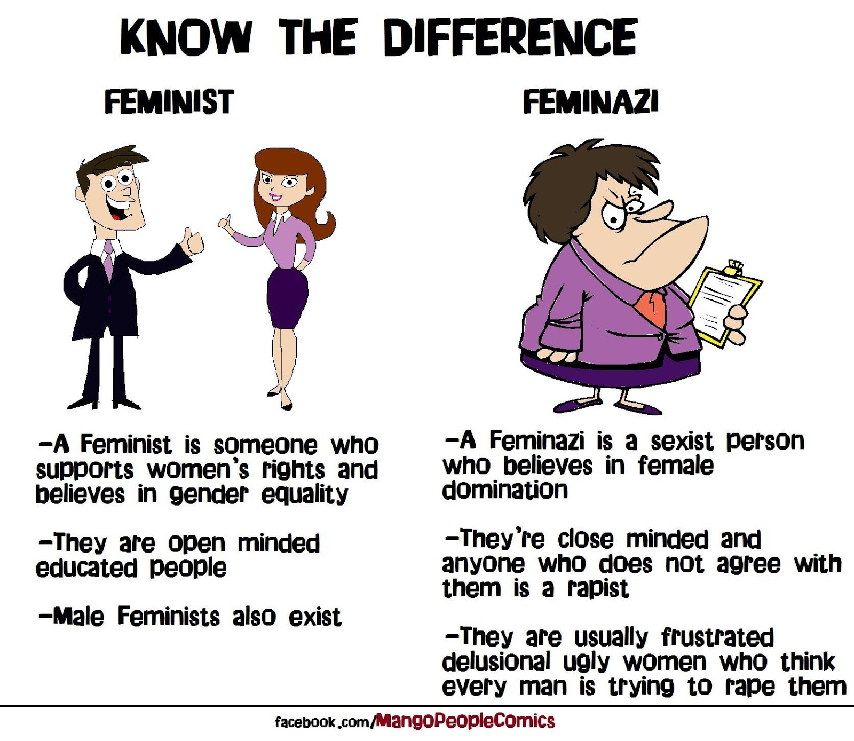

There have been various pieces of evidence that in the name of Feminism, these Femi-nazis have managed to destroy the lives of various youngsters and men and even after that, manages to move freely and independently everywhere. Is this what Feminism needs to do? Where is the fight for equality by feminists? Because, what I see in this decade is Femi-nazi and not feminists and their fake fights for glory, bad habits, and having night outs. Funny, right! Because if this is what Feminism is in this decade, then no women would seek equality in this name!

This is an irony of how the fake feminist looses free and innocent men accused by them gets their lives sucked up!

There are shreds of evidence of how the popular singer Beyonce promotes feminism and equality in her songs and ends up being a Femi-nazi by herself abusing her female staff and paying them less for Ivy Park.

Why go so far when there are massive cases of fake feminism in India itself! In 2015, Jasleen Kaur from Delhi filed fake molestation and sexual harassment case against Sarvjeet Singh. The case lasted for 4 years during which the innocent man lost his job, got a title of “Delhi ka Darinda” and also got pointed out as a “Pervert” by Arnab Goswami on the national television. This man lost everything including his character and status during this case and the fake feminist Jasleen Kaur stayed at Canada missing the case trials in the name of studies! With the accusation proved false, Singh sought apologies and restoration of his image by the journalists. But, what will bring back his lost 4 years?

This is not the only case where such fake feminists are not punished by law. Many women use feminism to loot and blackmail innocent men and their families in the name of harassments and filing false cases. Even after getting proved innocent, many of these families get destroyed by depression and humiliation caused by society. Women fight to wear cheap and revealing dresses, to drink and smoke, and party at night in the name of Feminism!

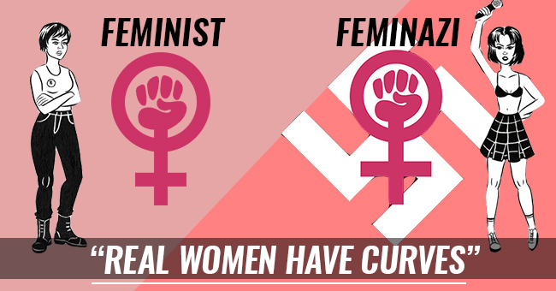

Bollywood even framed Ranbeer Kapoor as a playboy after his various relationships but not Deepika Padukone even after her number of ex relations being more than Ranbeer’s. Isn’t this wrong? A woman can do anything in the name of Feminism but a man cannot do the same!

Recently, Neha Dhupia was in the spotlight of the Fake feminism when in Roadies, she shouted at Karan, a candidate about how it is a woman’s choice to keep 5 relationships and slap him in front of anyone but he cannot do the same. Freshly, Femi-nazi had also destroyed a boy’s life because of false accusations. Manav Singh, a class 12th boy from Gurugram committed suicide in the stress of false accusations of rape. On this, the girl posted after innocent Manav’s death that it’s not her fault that he couldn’t manage the stress.

How shameless this is! How can anyone live on with their lives after destroying some body’s life, their family, character, and everything! This is not Feminism! And, because of these Femi-nazis,’ actually tortured women suffer that no one believes them at first because of these lessons!

